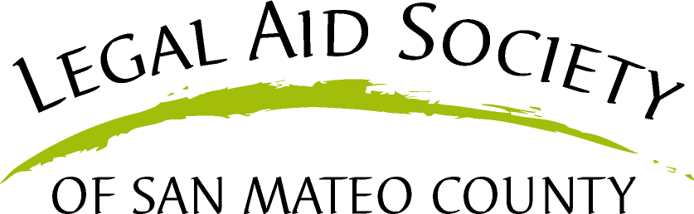

*The Natalie Lanam Justice Center Sobrato Center for Nonprofits-Redwood Shores*

*330 Twin Dolphin Drive, Suite 123 Redwood City, CA 94065*

***Form updated Dec. 2021***

**IF YOUR PATIENT HAS A LEGAL EMERGENCY CALL (650) 517-8904. OTHERWISE, OUR PROGRAM WILL ATTEMPT CONTACT WITHIN 3 BUSINESS DAYS.**

**Parent’s email address:**

Provider Signature

**Please fax form to: (650) 517-8973 and/or email FAP coordinator, Jessica Arevalo at** [**jarevalo@legalaidsmc.org**](mailto:jarevalo@legalaidsmc.org) **with a brief explanation of your concerns.**

◻

◻

◻

◻

◻

◻

◻

◻

◻

◻

◻

◻

◻

◻

◻

Health Insurance Medical Bills

Housing Problems (tenant rights) Disability Benefits

Welfare

Food Stamps/Cal Fresh WIC

Employment Rights

Domestic Violence Child Support

Child Custody/Visitation

Guardianship (non-parent caring for minor) Immigration

Special Education Other:

I, , authorize the Family Advocacy Program to notify the clinician listed on this form that I have had a consultation with the Family Advocacy Program and whether FAP was able to help resolve my problem or refer me to other resources. I also authorize the Family Advocacy Program to notify my clinician if the Program is unable to contact me.

Patient/Representative Signature

Date

**The Peninsula Family Advocacy Program**

**A Medical-Legal Partnership for Children**

**REFERRAL SOURCE**

**Provider’s Name:**

**Child’s Name:**

**Type of Provider:**

**Child’s Date of Birth:**

**Provider Pager:**

**Family’s Phone #:**

**Provider Phone #:**

**Other Contact #:**

**Attending Name:**

**Parent Name:**

**Consultation Date:**

**Preferred Language:**

**Family lives in City:**

**County:**

**Complex Care Patient? Yes No**

**PRESENTING PROBLEM(S) (check all that apply)**



**Parent’s email address:**

**IF YOUR PATIENT HAS A LEGAL EMERGENCY CALL (650) 517-8904. OTHERWISE, OUR PROGRAM WILL ATTEMPT CONTACT WITHIN 3 BUSINESS DAYS.**

Provider Signature

**Please fax form to: (650) 517-8973 and/or email FAP coordinator, Jessica Arevalo at** [**jarevalo@legalaidsmc.org**](mailto:jarevalo@legalaidsmc.org) **with a brief explanation of concerns.**

◻

◻

◻

◻

◻

◻

◻

◻

◻

◻

◻

◻

◻

◻

Health Insurance Medical Bills

Housing Problems (tenant rights) Disability Benefits

Welfare

Food Stamps/Cal Fresh WIC

Employment Rights

Domestic Violence Child Support

Child Custody/Visitation

Guardianship (non-parent caring for minor) Immigration

Special Education Other:

◻

Yo, , autorizo que el Programa de Abogacía para Familias avise al proveedor de servicios de salud (el nombre de quien está escrito en este formulario) que he tenido una consulta con el Programa de Abogacía para Familias y si el Programa fue capaz de ayudarme a resolver el problema o referirme a otros recursos. También autorizo que el Programa de Abogacía para Familias avise mi proveedor de servicios de salud si el Programa no puede contactarme.

Firma del Paciente/Representante

Fecha

*The Natalie Lanam Justice Center Sobrato Center for Nonprofits-Redwood Shores*

*330 Twin Dolphin Drive, Suite 123 Redwood City, CA 94065*

***Form updated Dec. 2021***

**The Peninsula Family Advocacy Program**

**A Medical-Legal Partnership for Children**

**REFERRAL SOURCE**

**Provider’s Name:**

**Child’s Name:**

**Type of Provider:**

**Child’s Date of Birth:**

**Provider Pager:**

**Family’s Phone #:**

**Provider Phone #:**

**Other Contact #:**

**Attending Name:**

**Parent Name:**

**Consultation Date:**

**Preferred Language:**

**Family lives in City:**

**County:**

**Complex Care Patient? Yes No**

**PRESENTING PROBLEM(S) (check all that apply)**